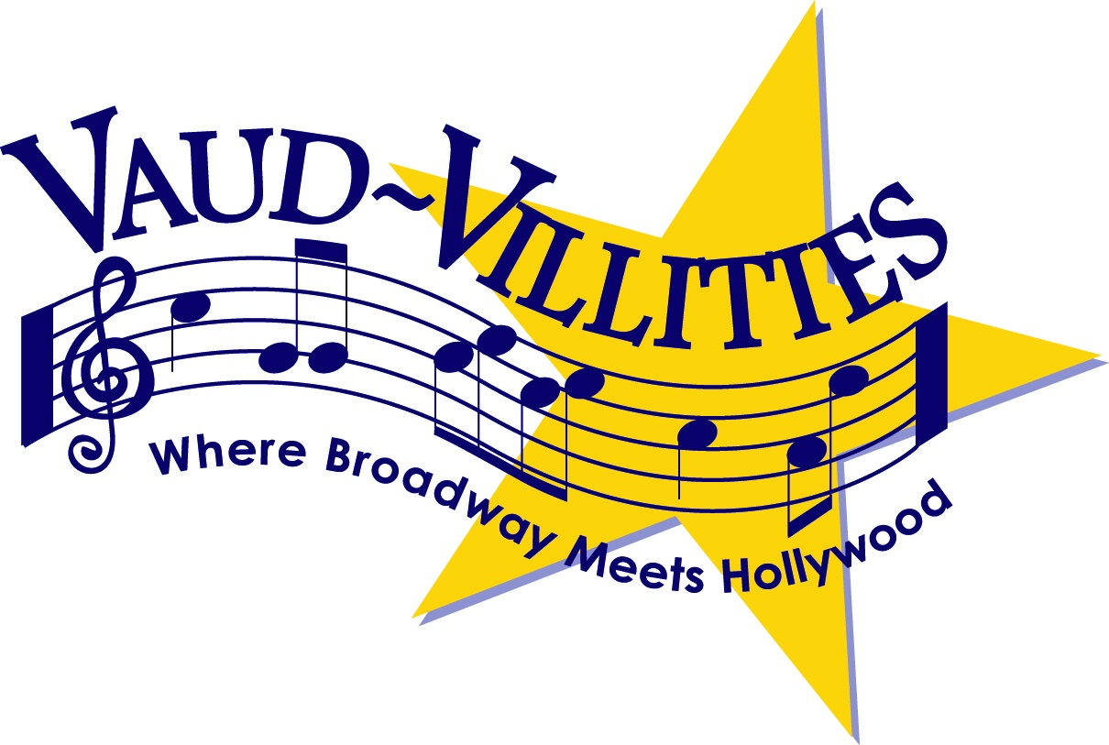

FOR IMMEDIATE RELEASE CONTACT: Karen Miller
Marketing Co-Chair
614-326-1226 karen.miller@ncm.com

VAUD-VILLITIES ANNUAL SPRING VARIETY SHOW: DIAMOND JUBILEE- A TRIBUTE TO 75 YEARS

Columbus non-profit performing arts organization, Vaud-Villities Productions, a favorite of the central Ohio theater community for over seven decades, will showcase the talent of its vocalists, dancers and choruses in its 75th annual variety show Diamond Jubilee- A Tribute to 75 years.
The longest running, family–friendly variety show in the country, features songs from all eras to delight audiences of all ages. Thrilling performances of hits such as Adele, Turning Tables; Rhianna, Diamonds; Justin Timberlake, Can’t Stop This Feeling to Vaud-Villities classics New York, New York, City Lights, and 42nd Street, choreographed by Tony Award winner, Randy Skinner, are just a few of the many crowd favorites in the production.
“We’re unique, we don’t work out of a book. Everything is original and there’s something really special about that,” says Russ Coffman, Producer.
Diamond Jubilee will be performed at 7:30 pm Thursday, April 20, 8:00 pm Friday, April 21, 2:30 and 8:00 pm Saturday April 22, and 2:30pm Sunday, April 23 at the Northland Performing Arts Center, 4411 Tamarack Bldv., Columbus, Ohio 43229
Adult tickets are $25, Seniors $20, Students $15, Youth 6-12 $10, and children 5 and under free.
Group rates are available for 11. For more information and to purchase tickets
Visit: www.vvshows.org or call 614-262-SHOW (7469)

